After the introducing of the configuration change add JMS workflow manager : allow 128 requestors instead of 16. ( to solve issue with inform handling queued for long time )

We now notice a Oracle error on the database stating: ‘enq: TX - allocate ITL entry’

These peaks occur when a high load of informs is reaching our platform.

DB stats:

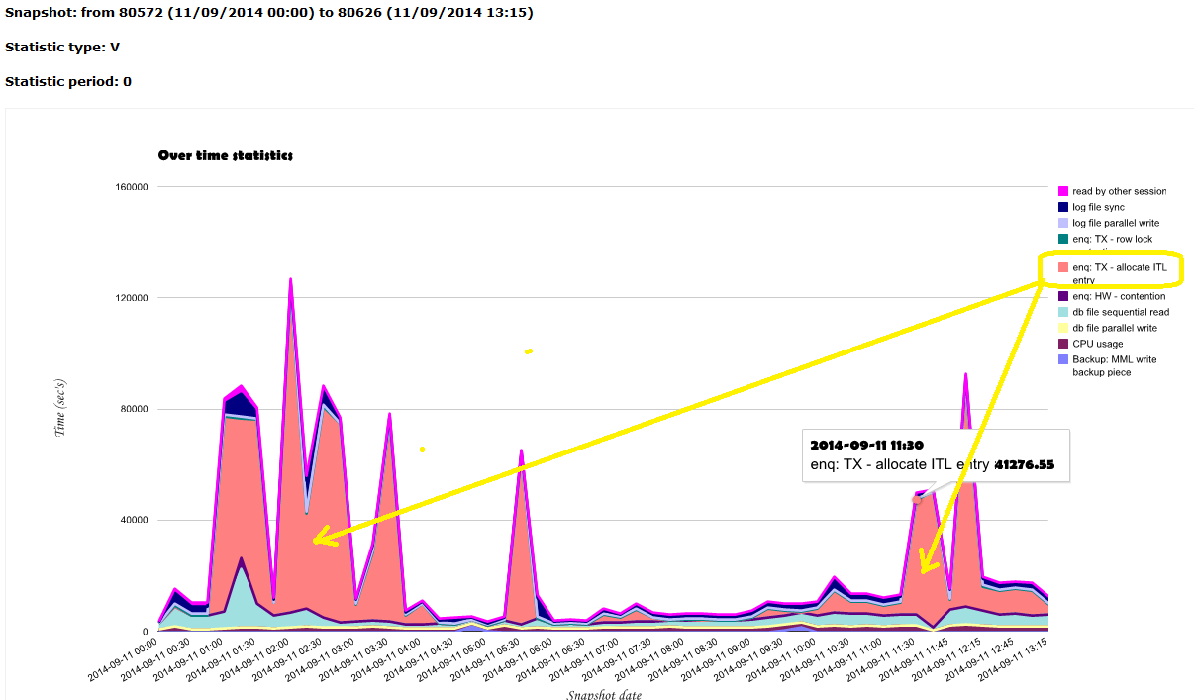

We contacted our dba, and this was the outcome:

This looks like the HW contention we see before on table SPRT_NC_INFORM_EVENT.

Load on this table is high. About 44 inserts and 44 deletes per second on peak load

This wait appears when concurrent dml transactions needs the same data block.

Default this setting is 1 for table and 2 for index. This means only 1 transaction can change the same data block.

This can be improved by setting INITRANS on a higher value, both for table and index.

As there is a high load on the table, a setting of 10 can be advised.

**Questions**: - Can you agree with this approach, or do you advice something else?

- Default is the INITRANS for table 1, and index 2, below table and index are set to 10,

Do you agree also?

- We also see that the JDBC web logic database connections are now more heavily used

and easy reach the defined platform of 200. Before, we only experienced these levels

when web logic got stuck and we had to restart web logic to free the system.

What is your recommendation here? Are they related to the 'allocate ITL entry’ lock?

( see fig 2 below)

How to change:

*alter table SPRT_NC_INFORM_EVENT INITRANS 10;*

*alter table SPRT_NC_INFORM_EVENT move;*

move 🡪 needed to have preference changes on all data blocks, both old and

*alter index BGC_SPRT_NC_INFORM_EVENT_IDX1 rebuild initrans 10;*

*alter index SPRT_NC_INFORM_EVENT_IDX1 rebuild initrans 10;*

*alter index SPRT_NC_INFORM_EVENT_IDX2 rebuild initrans 10;*

*alter index SPRT_NC_INFORM_EVENT_PK rebuild initrans 10;*

Note: Best done when application is down.

Table info:

|  |  |  |
| --- | --- | --- |
| TABLE_NAME | INI_TRANS | MAX_TRANS |
| SPRT_NC_INFORM_EVENT | 1 | 255 |

|  |  |  |
| --- | --- | --- |
| **SID** | **STATS INFO (SIZE, RECORDS) FOR TABLE** | **TIMESTAMP** |
| cpxp | SPRT_NC_INFORM_EVENT | 11/09/2014 13:52:35 |

. Table size info

|  |  |  |  |  |  |  |
| --- | --- | --- | --- | --- | --- | --- |
| **OWNER** | **SEGMENT_NAME** | **SEGMENT_TYPE** | **PARTITION_NAME** | **TABLESPACE_NAME** | **KBYTES** | **BLOCKS** |
| CPX_SCHEMA | SPRT_NC_INFORM_EVENT | TABLE |  | CPX_DATA | 81920 | 10240 |

. Index size info

|  |  |  |  |  |  |  |
| --- | --- | --- | --- | --- | --- | --- |
| **OWNER** | **SEGMENT_NAME** | **SEGMENT_TYPE** | **PARTITION_NAME** | **TABLESPACE_NAME** | **KBYTES** | **BLOCKS** |
| CPX_SCHEMA | BGC_SPRT_NC_INFORM_EVENT_IDX1 | INDEX |  | CPX_INDEX | 58368 | 7296 |
| CPX_SCHEMA | SPRT_NC_INFORM_EVENT_IDX1 | INDEX |  | CPX_INDEX | 37888 | 4736 |
| CPX_SCHEMA | SPRT_NC_INFORM_EVENT_IDX2 | INDEX |  | CPX_INDEX | 33792 | 4224 |
| CPX_SCHEMA | SPRT_NC_INFORM_EVENT_PK | INDEX |  | CPX_INDEX | 39936 | 4992 |
| CPX_SCHEMA | SYS_IL0000010948C00015$$ | LOBINDEX |  | CPX_DATA | 76800 | 9600 |

. Table stats info

|  |  |  |  |  |  |  |  |  |  |
| --- | --- | --- | --- | --- | --- | --- | --- | --- | --- |
| **TYPE** | **NAME** | **BLOCKS** | **NUM_ROWS** | **LAST_ANALYZED** | **INSERTS** | **UPDATES** | **DELETES** | **TIMESTAMP** | **T** |
| Table | SPRT_NC_INFORM_EVENT | 10097 | 1027 | 06/09/2014 19:08:00 | 12390431 | 982286 | 12372268 | 11/09/2014 00:58:24 | N |

Fig 2: JDBC stats

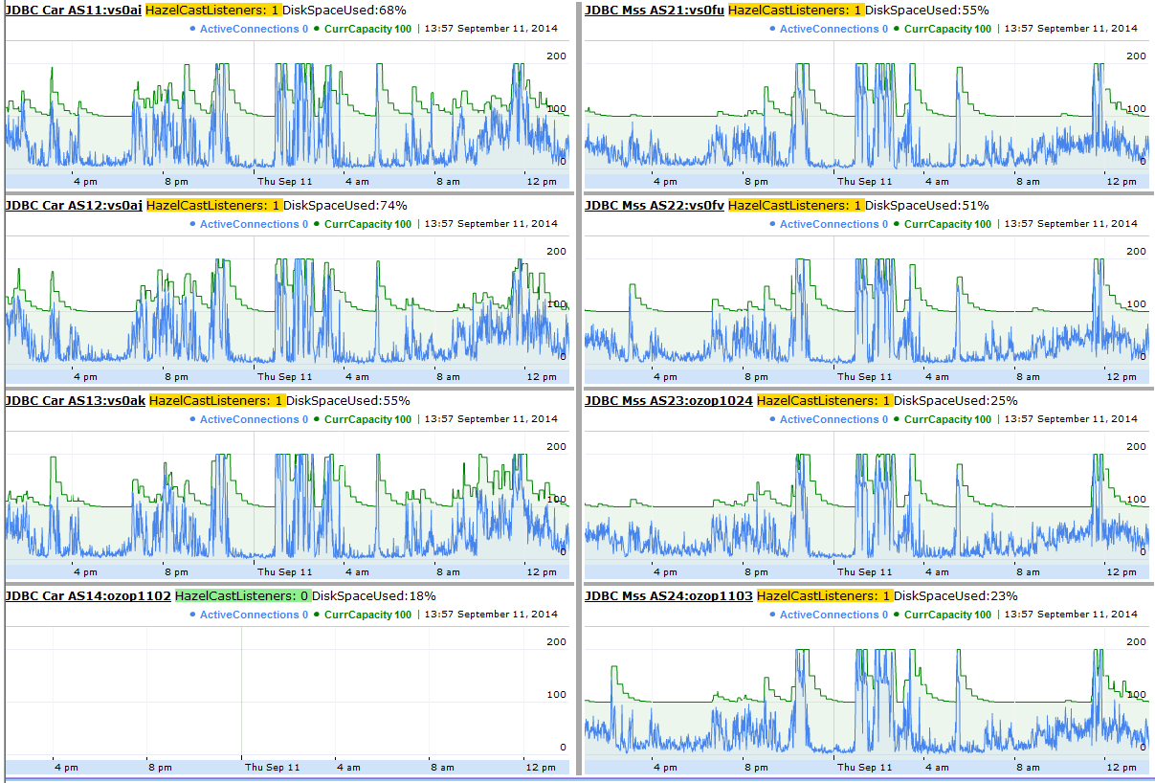

Incoming traffic:

