Setup of OOTB test SG4.1.1 regarding FW issue 24049

Firt I setup a template called tpl-test with one Parameter group Set Parameter:

InternetGatewayDevice.DeviceInfo.ProvisioningCode= $!device.attribute.get('DnsServers')

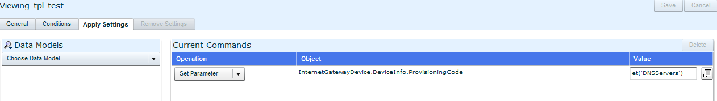

Second I created 2 services: first_1 and Second-2 with different priorities: 4 and 5

To both services I only configured template tpl-test with delivery rule: On Change.

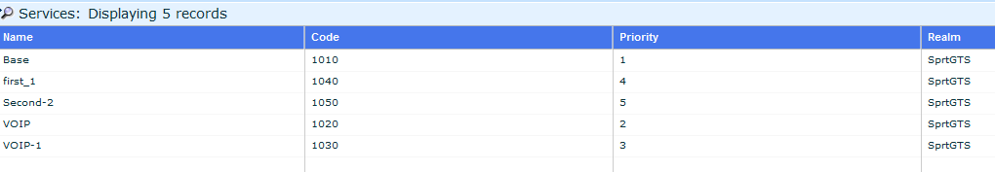

I setup the Default Configuration and Synchronization policy to deliver the 2 services to the device.

When the device bootstraps I receives the 2 services in the DB and in the DBoR in first instance only 1 template is delivered: tpl-test Service name first_1

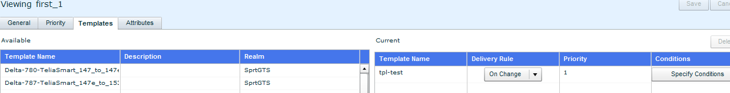

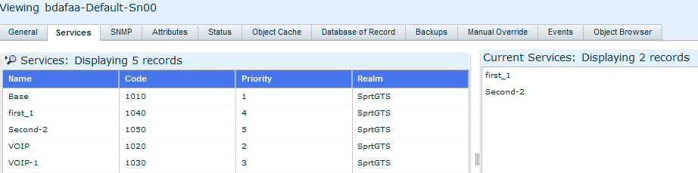

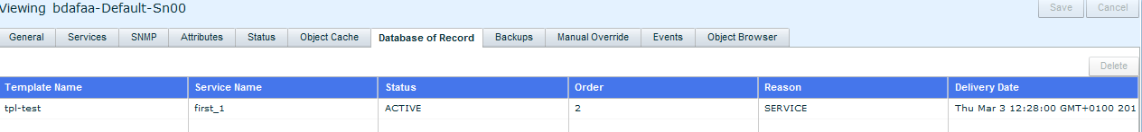

Then I make a small change in the template e.g. $!device.attribute.get('DNSServers') save it and via the CSR interface I force an update of the services/templates.

Suddenly 2 templates show up in the DBoR: also one from the second service with lower priority, first entry is moved.

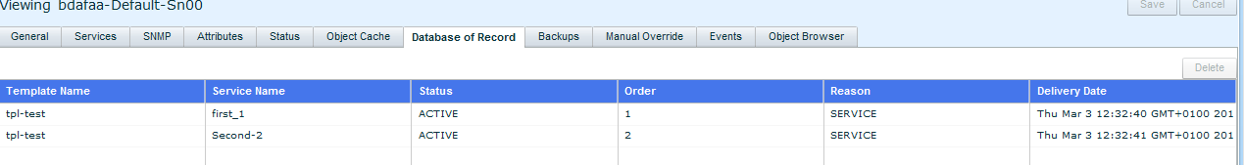

I make another change in the template: and now there are 3 entries in the DBoR: both services with updated template. And one of the previous entries.

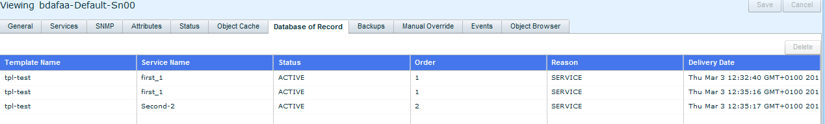

When I make a third change and update the device the DBoR shows: 4 entries but now only the Second-2 service template is applied/stored.

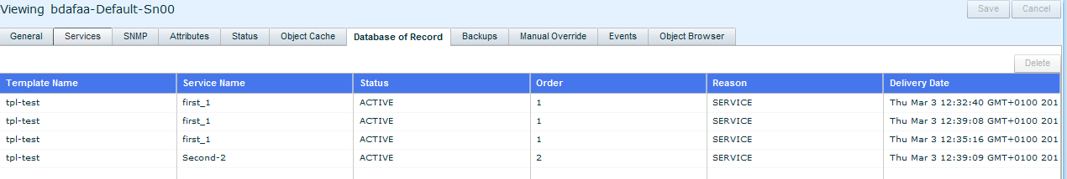

The complaint from FW is that the DBoR becomes a bit a mess, they use many more templates per service and also service combinations.