|  |
| --- |
| Consona Corporation |
| Summary of Changes |
| To Address DB Performance Issue |
|  |
| **Paul Miechels** |
| **1/19/2012** |

|  |
| --- |
|  |

**Below are all the steps taken to gain performance.**

# Background

There appeared to be 2 TOP queries shown in the AWR report taken just after the previous upgrade to SG4.1.4:

UPDATE sprt_ec_device SET ip_address = null WHERE ip_address = :1 AND unique_id_string != :2;

SELECT 1 FROM sprt_ec_device WHERE ip_address = :1 AND id != :2;

The first one was resolved by adding an extra index on the sprt_ec_device table called IDXJES. But the behavior of the second TOP query could not be influenced by adding an extra index.

We did notice the same behavior at other customers and there it was solved by using the SQL profiler, part of Oracle Enterprise Manager, so Andrew Matheson suggested that to your DBA including some other DB changes.

1. Use Oracle Enterprise Manager to run SQL Tuning Advisor on the query to find a better optimizer profile.
2. Change the optimizer settings.

# Oracle EM SQL Tuning Advisor

After starting the EM on the Oracle server we could use SQL profiler and followed the suggested improvement of the second query, check screenshots about the suggestion, the next step and the improvement it caused immediately.

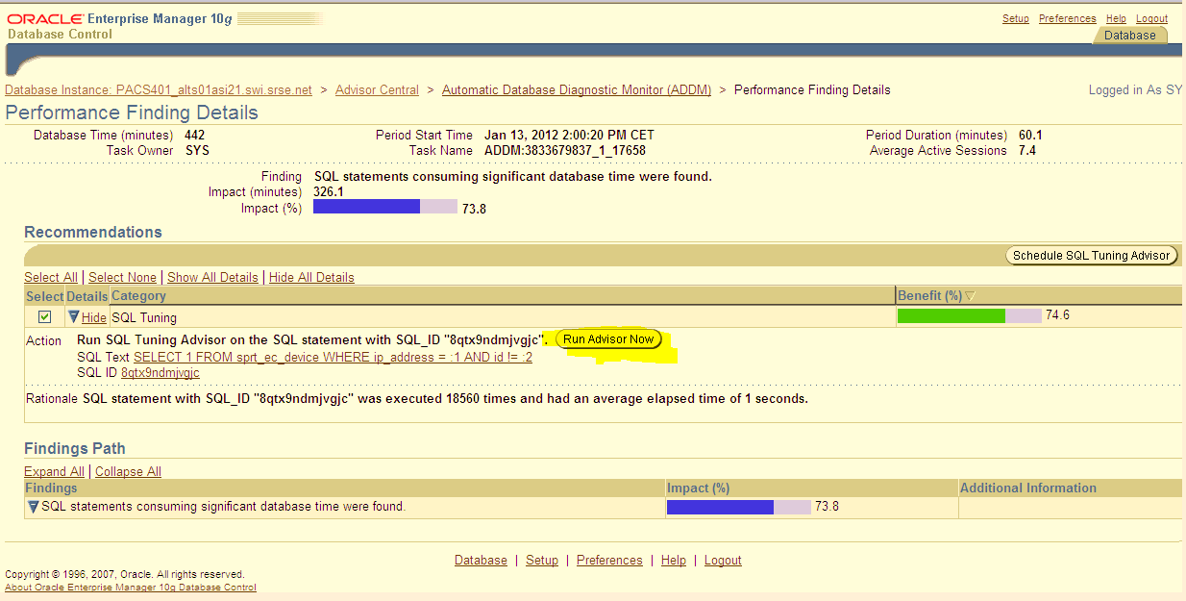

Figure 1 - Oracle EM Tuning Advisor

The outcome of the advisor is shown here below:

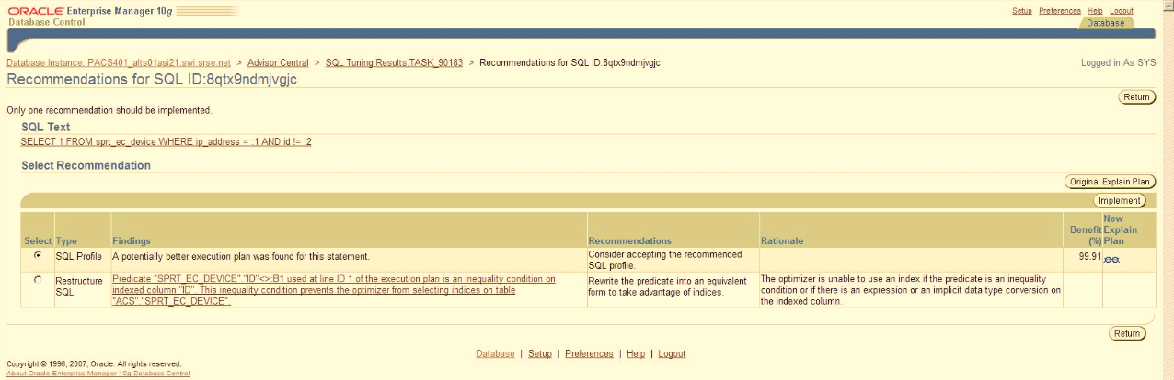

Then we pressed the ‘implement’ button and the result was immediately visible in EM monitoring: The load average dropped 50% as was expected.

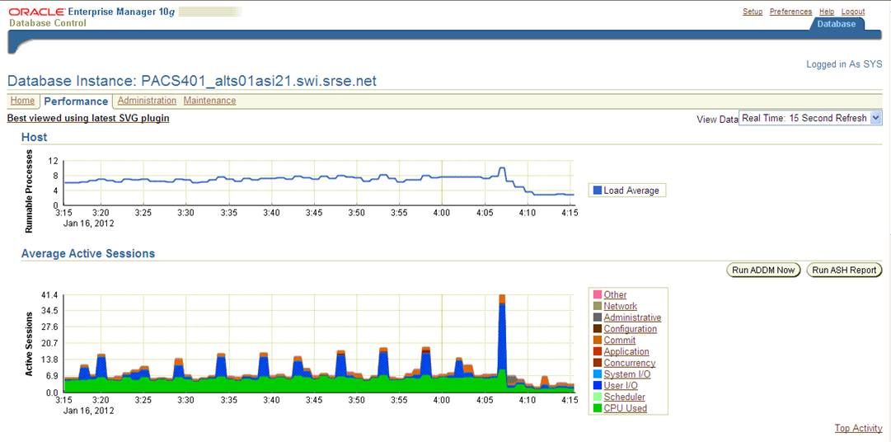

And also the EXPLAIN PLANS on both queries showed that the first query was not influenced by the improvement of the second query:

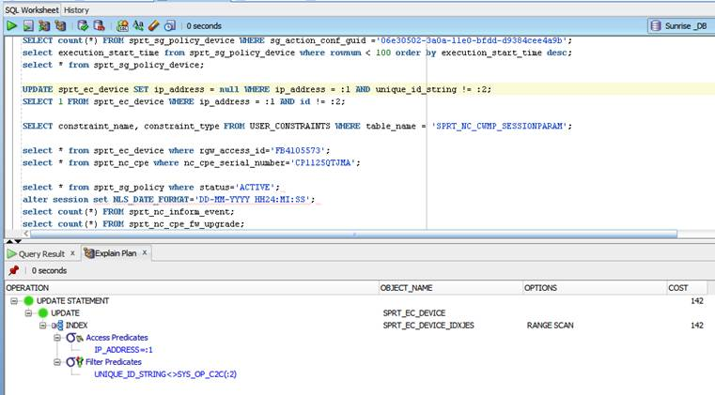

The improvement of the second query saw the costs drop from 4458 to 4, now using a Range Scan instead of a Full table scan.

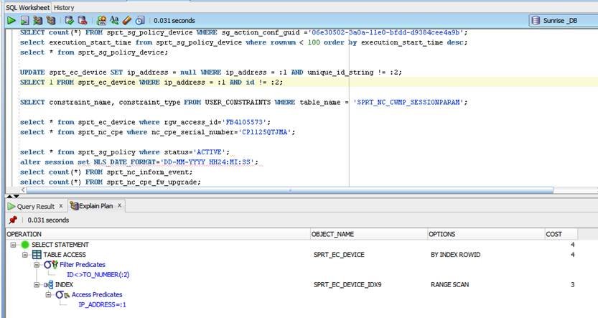

# Changed Event Queue Settings

The next step I made was regarding the Event queuing settings in the ServiceGateway GUI under Administrator> Settings> Preferences>CWMP:

I changed the settings from:

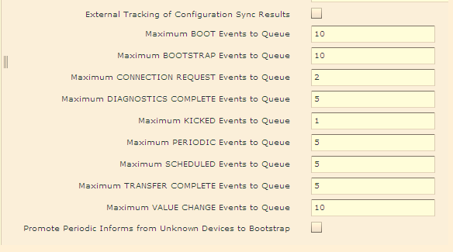

Into:

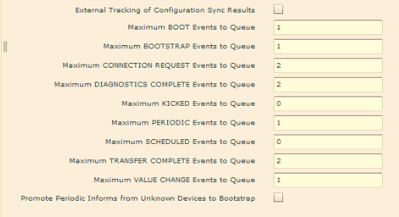

This change together with the improvement in DB performance took care there are no remaining devices in the frequently used policies.

# Steps that still need to be taken

1. Changing the optimizer settings mentioned by Andrew in an email to Miha Jerebic:

ALTER SYSTEM SET optimizer_index_caching=75 scope=both;

ALTER SYSTEM SET optimizer_index_cost_adj=10 scope=both;

This will improve how the optimizer works, but will require a DB restart

1. The concurrency of the Default Configuration Synchronization policy should be increased from 100 to 200.